Grid-Tied, Off-Grid and Hybrid Solar Systems

**What are the benefits of grid-connected solar panels vs. living off the grid?** Deciding whether or not to grid-tie your solar panels is usually pretty straightforward – the clear-cut benefits of being grid-tied appeals to the majority of homeowners. There are, however, some people that choose to live off the grid.

## **Grid-Tied Solar Systems**

Grid-tied, on-grid, utility-interactive, grid intertie and grid back feeding are all terms used to describe the same concept – a solar system that is connected to the utility power grid.

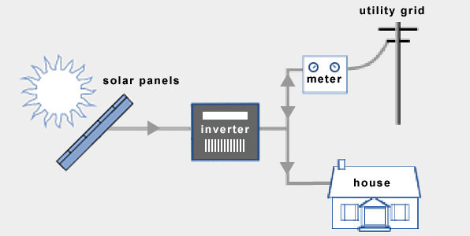

### **Advantages of Grid-Tied Systems**

#### **1. Save more money with net metering**

**A grid-connection will allow you to save more money with solar panels through better efficiency rates, net metering, plus lower equipment and installation costs:**

Many utility companies are committed to buying electricity from homeowners at the same rate as they sell it themselves.

#### **2. The utility grid is a virtual battery**

**The electric power grid is in many ways also a battery, without the need for maintenance or replacements, and with much better efficiency rates.** In other words, more electricity (and more money) goes to waste with conventional battery systems.

### **Equipment for Grid-Tied Solar Systems**

There are a few key differences between the equipment needed for grid-tied, off-grid and hybrid solar systems. Standard grid-tied solar systems rely on the following components:

* Grid-Tie Inverter (GTI) or Micro-Inverters
* Power Meter

## **Off-Grid Solar Systems**

An off-grid solar system (off-the-grid, standalone) is the obvious alternative to one that is grid-tied. For homeowners that have access to the grid, off-grid solar systems are usually out of question. Here`s why:

To ensure access to electricity at all times, off-grid solar systems require battery storage and a backup generator (if you live off-the-grid). On top of this, a battery bank typically needs to be replaced after 10 years. Batteries are complicated, expensive and decrease overall system efficiency.

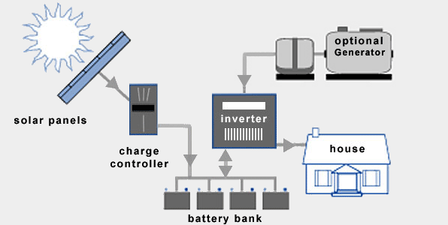

### **Advantages of Off-Grid Solar Systems**

#### **1. No access to the utility grid**

**Off-grid solar systems can be cheaper than extending power lines in certain remote areas.**

#### **2. Become energy self-sufficient**

### **Equipment for Off-Grid Solar Systems**

Typical off-grid solar systems require the following extra components:

* Solar Charge Controller
* Battery Bank
* DC Disconnect (additional)
* Off-Grid Inverter
* Backup Generator (optional)

## **Hybrid Solar Systems**

Hybrid solar systems combines the best from grid-tied and off-grid solar systems. These systems can either be described as off-grid solar with utility backup power, or grid-tied solar with extra battery storage.

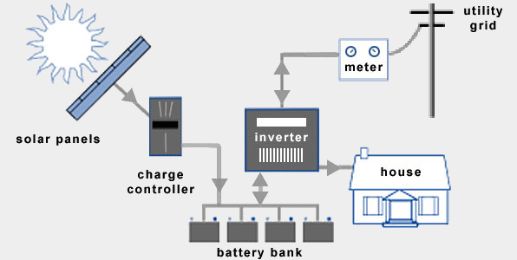

### **Advantages of Hybrid Solar Systems**

#### **1. Less expensive than off-gird solar systems**

**Hybrid solar systems are less expensive than off-grid solar systems.** You don`t really need a backup generator, and the capacity of your battery bank can be downsized. Off-peak electricity from the utility company is cheaper than diesel.

#### **2. Smart solar holds a lot of promise**

**The introduction of hybrid solar systems has opened up for many interesting innovations.**

**Smart solar holds a lot of promise. The concept will become increasingly important as we transition towards the smart grid in the coming years.**

### **Equipment for Hybrid Solar Systems**

Typical hybrid solar systems are based on the following additional components:

* Charge Controller
* Battery Bank
* DC Disconnect (additional)
* Battery-Based Grid-Tie Inverter
* Power Meter

References:

1. <https://www.builddirect.com/blog/different-types-of-solar-energy-systems-for-your-home/>
2. <https://understandsolar.com/solar-power-without-batteries/>
3. <https://www.eia.gov/tools/faqs/faq.php?id=105&t=3>
4. <https://www.cleanenergyauthority.com/solar-energy-resources/3-types-of-residential-solar-electric-power-systems>
5. <https://www.waynesolar.com/solar-electric-systems.shtml>